**Quantitative Methods**

**Final Exam __________________________________**

**Summer 2013, Hill *name***

*About the data: the data used to generate all SPSS output in this exam is real data from the Framingham Heart Study. The study records longitudinal data on demographic characteristics and health outcomes to identify the common factors that contribute to cardiovascular disease. In the study, 5,209 men and women have been followed biennially since 1948.*

1. Using the graph below, describe the distribution of age of death, by sex. (5 points)

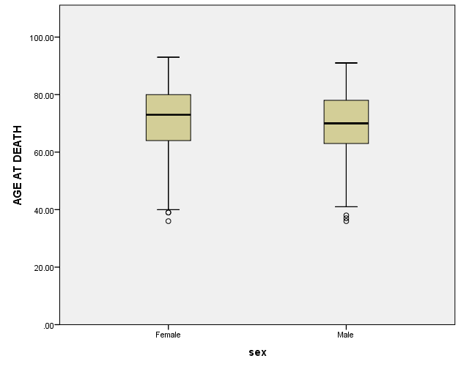

2. Using the graph below, thoroughly describe the nature of the relationship between age at death and cigarette consumption. (10 points)

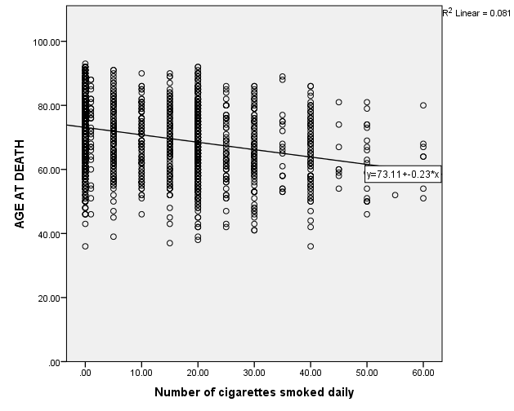

3a. Interpret and thoroughly describe the following output. Indicate the type of hypothesis test used. Specify the dependent variable and the independent variable(s). What might the researcher be trying to do, and what do you suppose the hypothesis is? In detail, interpret the results—describing the results with a conversational tone, but also reporting the important technical details. (15 points)

3b. If someone smokes two packs (40 cigarettes) per day, estimate the change in their life expectancy. Use the output below. (5 points)

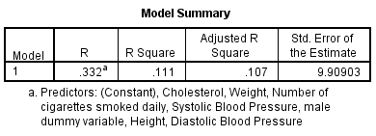

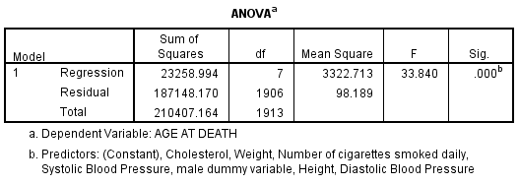

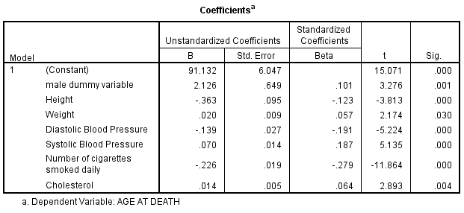

*additional room to answer question 3a/3b*

3c. What does the following output add to your understanding of the output in question 3a? Do you see any potential problems? How do you know whether or not these problems exist? What would you do to fix these problems? (5 points)

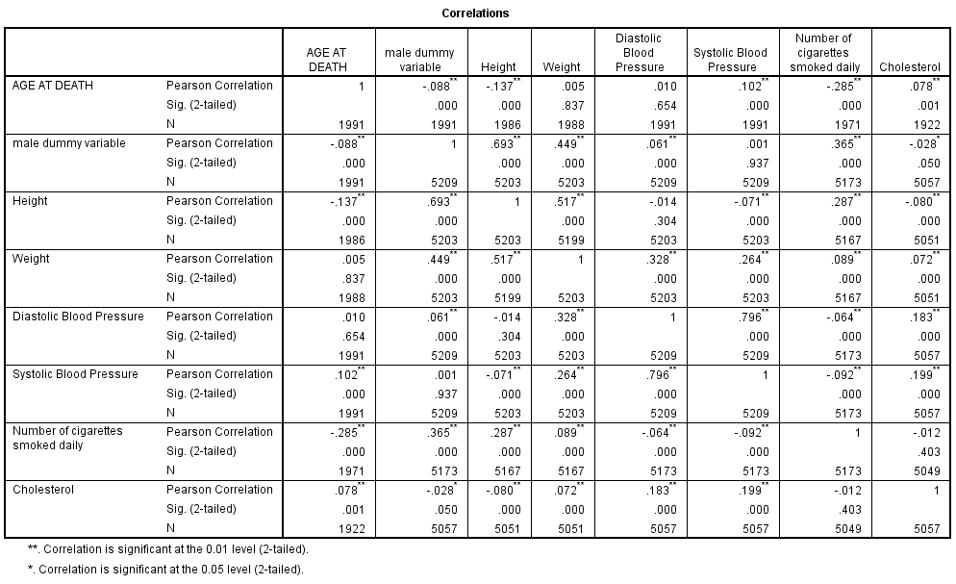

4a. Interpret and thoroughly describe the following output. Indicate the type of hypothesis test used. Specify the dependent variable and the independent variable(s). What might the researcher be trying to do, and what do you suppose the hypothesis is? In detail, interpret the results—describing the results with a conversational tone, but also reporting the important technical details. (15 points)

4b. Interpret and describe the appropriate measure(s) of association/correlation (5 points)

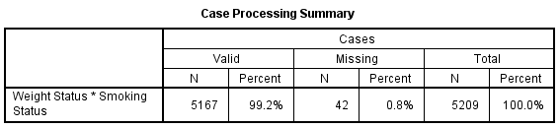

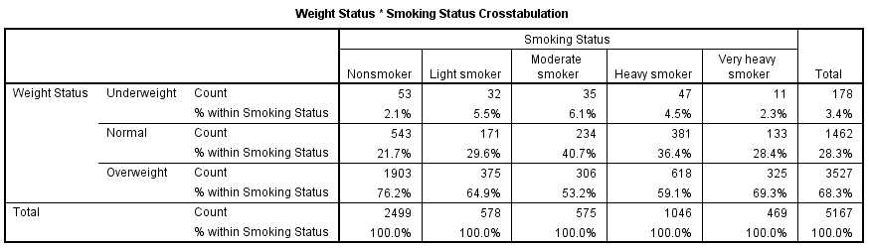

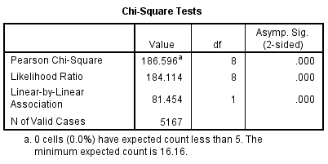

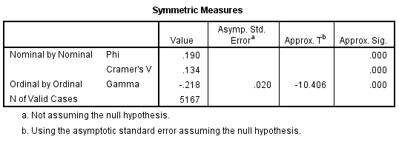

*additional room to answer question 4a/4b*

5. Interpret and thoroughly describe the following output. Indicate the type of hypothesis test used. Specify the dependent variable and the independent variable(s). What might the researcher be trying to do, and what do you suppose the hypothesis is? In detail, interpret the results—describing the results with a conversational tone, but also reporting the important technical details. (15 points)

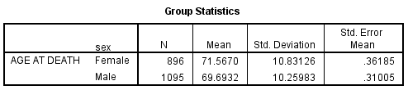

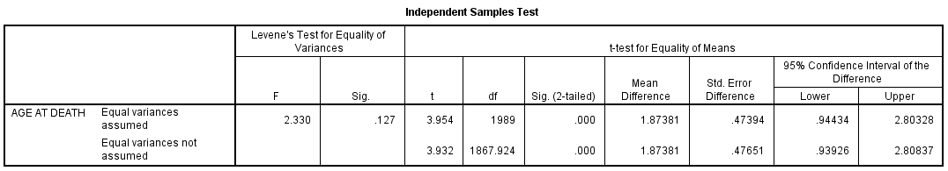

6. Interpret and thoroughly describe the following output. Indicate the type of hypothesis test used. Specify the dependent variable and the independent variable(s). What might the researcher be trying to do, and what do you suppose the hypothesis is? In detail, interpret the results—describing the results with a conversational tone, but also reporting the important technical details. (15 points)

**weight** = person’s weight in pounds

**blood pressure** is measured as: Desirable, Borderline, or High

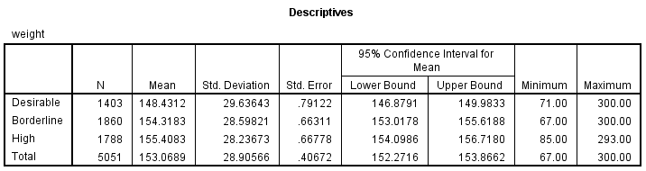

blood  
pressure

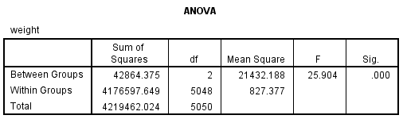

7. List five ways that you might use statistics in your career (5 points):

8. Drawing from what you learned in this course, how would consumers fare in the long term if the penny were eliminated? Would consumers be better off or worse off? How and why? (5 points):